

**Fatih Bildirici – 23823406**

**Ankara University Artificial Intelligence PhD Programme**

**Machine Learning with Python Course**

**Minilab 7 Answers**

Example 1:

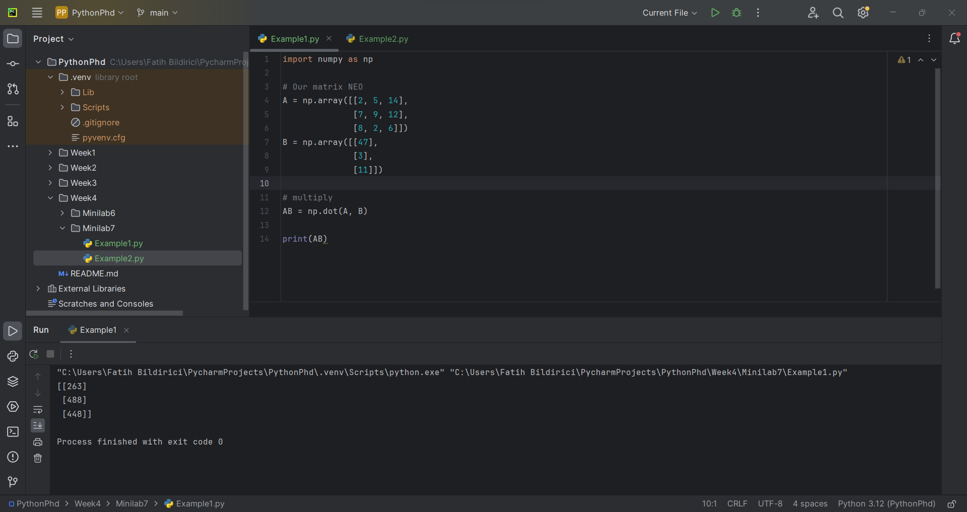

Example 2:

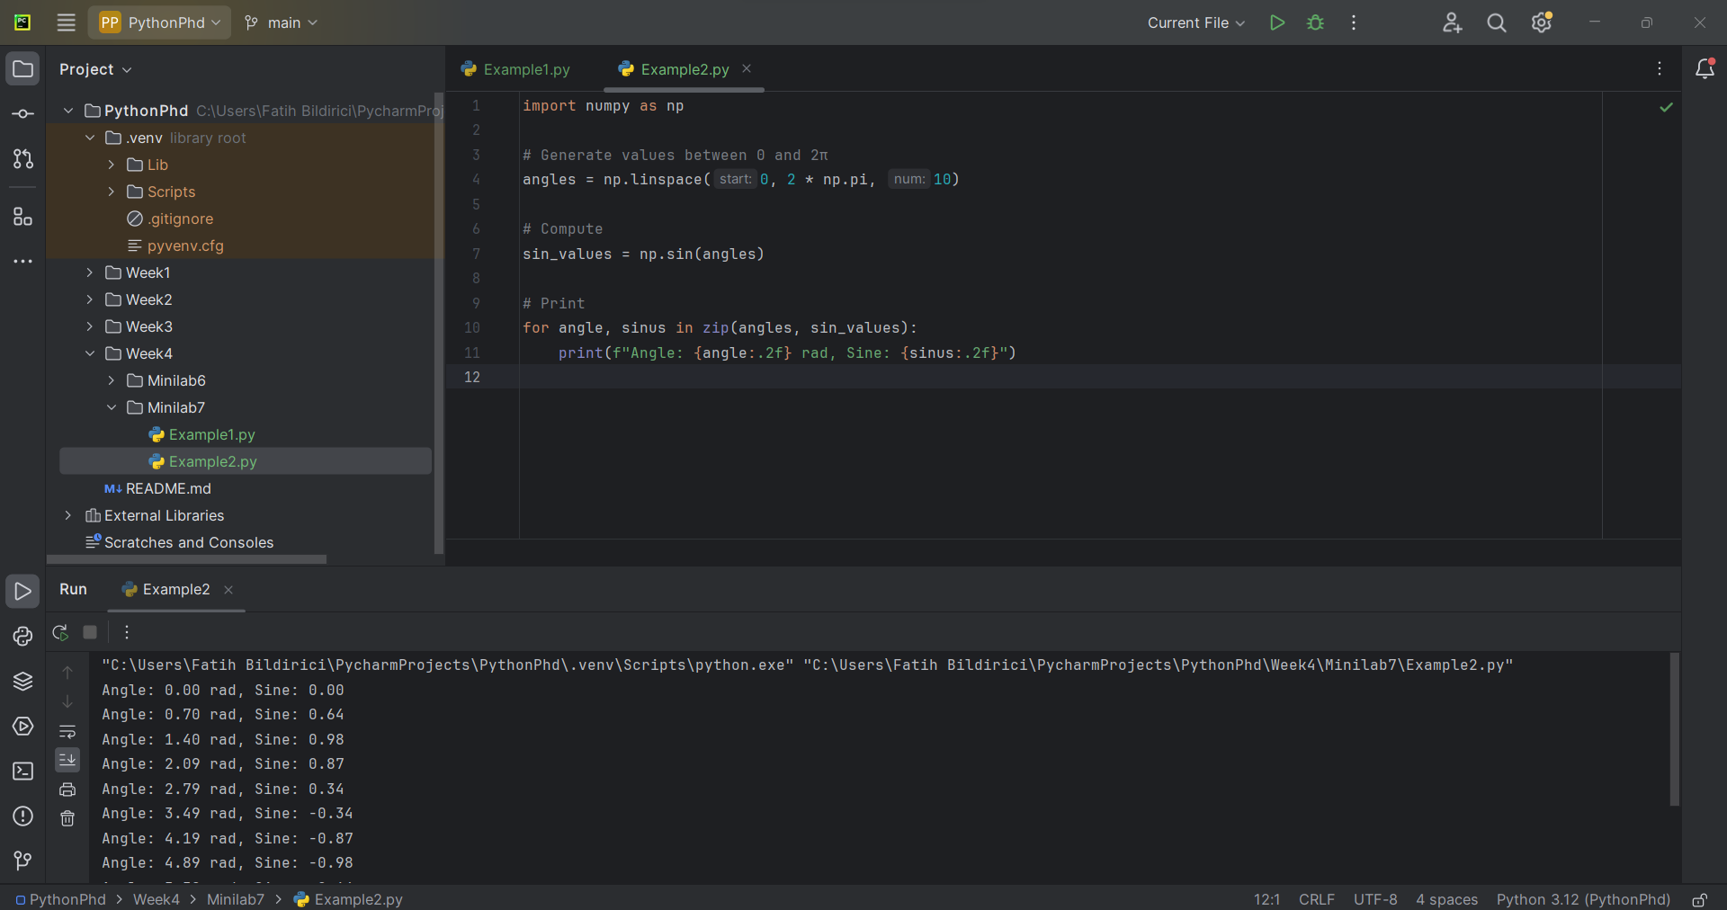

Example 3:

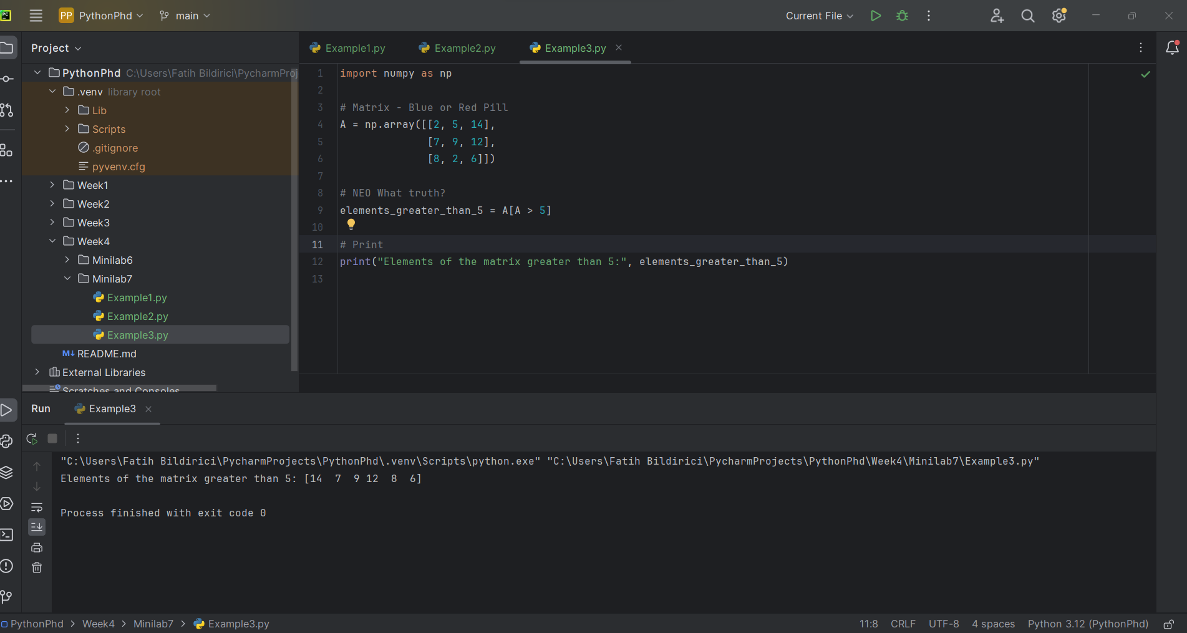

Example 4:

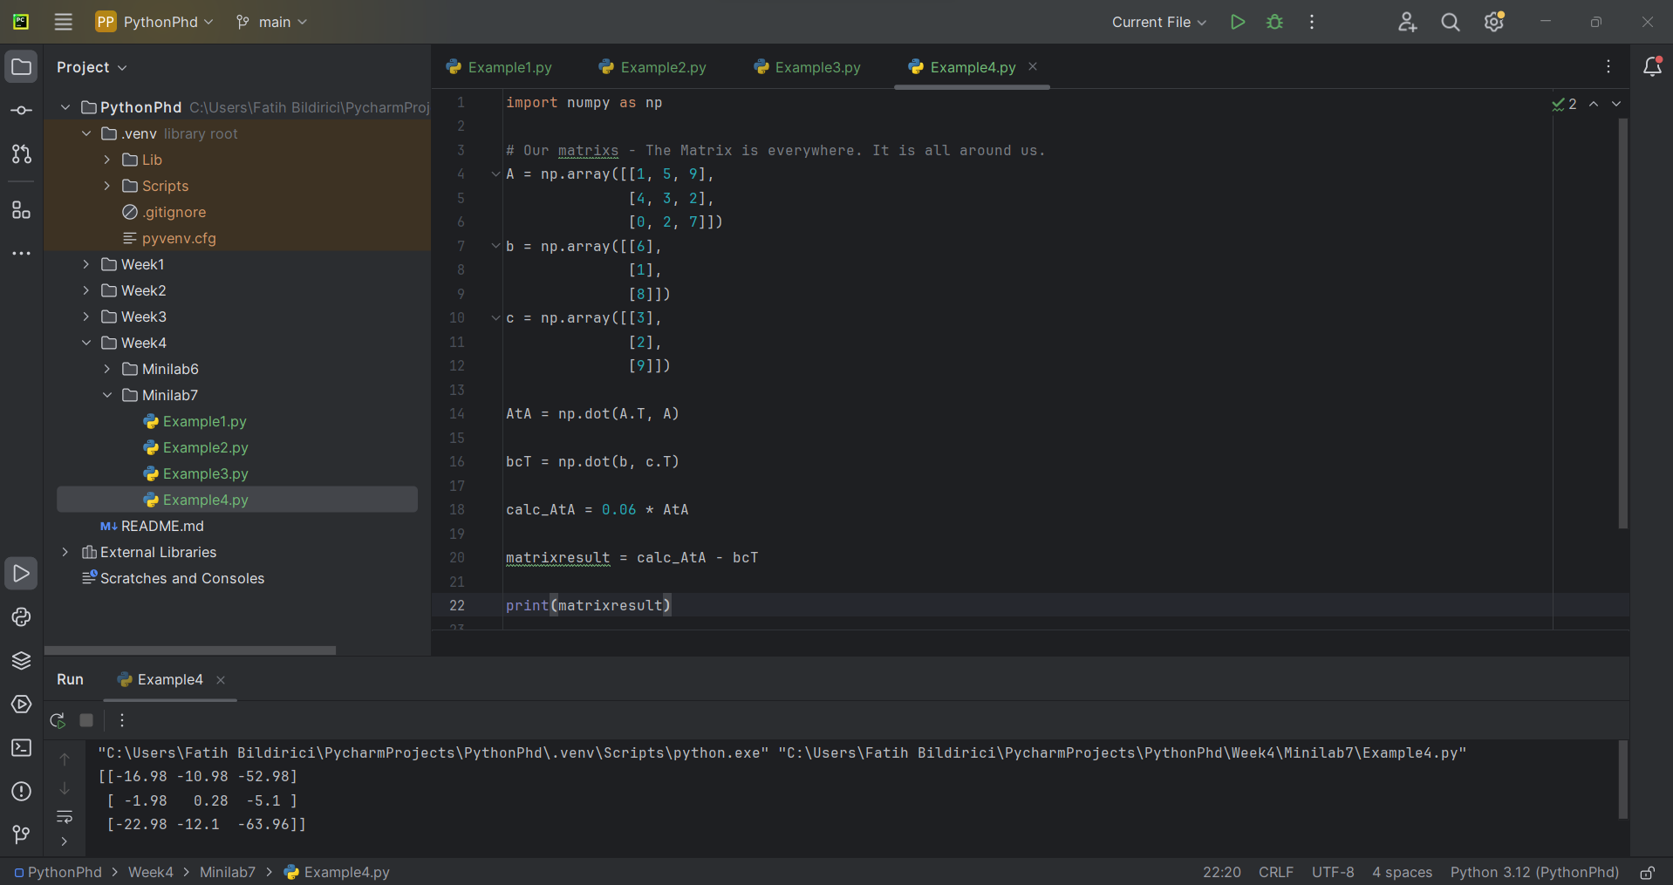

Example 5:

